Tracking Down Fife’s Ancient Legal Centre

It has long been accepted by scholars familiar with the earliest writings that Fife’s ancient legal centre was located at a place called Dalginch, close to Markinch. Dalginch is listed in the Bute and Berne manuscripts alongside other regional centres that have held on to their regional importance – Aberdeen, Scone, Inverness, Forfar and several others. These were all important places, designated for assembling stolen goods (usually cattle) prior to adjudication on their ownership, and were effectively regional capitals. As the Gaelic Scots began to piece together a kingdom north of the Forth, they are likely to have retained the old Pictish assembly areas. Dalginch is close to the border of the ancient sub kingdoms of Fife and Fothriff and the proven legal function of the 12th-13th century may represent an even earlier role linked to the resolution of disputes, inauguration ceremonies and public debate.

The problem has always been that old maps are unclear as to where Dalginch actually was. According to the newly published book “The Place Names of Fife Vol. II” by Dr Simon Taylor and Gilbert Márkus, the name means “thorn inch” An “inch” can mean an island, raised land in a bog or land beside a river (thorn trees or thorn hedges were often associated with assembly areas). The present day farmhouse called Dalginch, high on the slopes above Markinch fits into none of these descriptive categories, and it is proposed in the book that the name has been transplanted from somewhere close by. Dr Taylor and his co-author Gilbert Márkus, both medievalists from Glasgow University, argue that the most likely site was the prominent mound in the crook of the Markinch Burn where Northhall cemetery was located in the 1850s (see photo below).

The Dalginch estate would have been a major medieval landholding centred on a manorial dwelling house somewhere in the vicinity of Northhall, perhaps including the church of Markinch. We have charter evidence that there was a Hill of Dalginch, a mill of Dalginch, a Dalginch Myre, a Star of Markinch and a Dalginch Common. The estate came to be known as the barony of Brunton and Dalginch and the manor house probably relocated to a less restricted site where Brunton House once stood. Perhaps initially a “south hall” was built here but there is no charter evidence of this name. The barony was reinstated by Charles II and granted to the Law family but it was later subdivided into two major vertical strips. The easternmost holding was bought by the Paxton family and it is believed that they built the present day house of Dalginch, named after the nearby hill of the same name. Over time, encouraged by antiquarians, it came to be accepted by the local population as the site of the old sheriff court. However, the earliest estate plans make no reference to a farm called Dalginch, only to Bowhouse and Braes.

Simon Taylor and Gilbert Márkus draw attention to the importance of Northhall. Before the cemetery was laid out in the 1850s and prior to the coming of the railway, Northhall mound was surrounded on three sides by the Markinch Burn and connected to Markinch Hill by a narrow neck of land.

The book argues further that the name Markinch meaning “Horse Inch” was likely to be the place where the men of Fife (and presumably Fothriff) kept their steeds while assemblies took place, showing them off, trading or racing them on the flatter lands close by.

A third “inch” is identified on the south eastern edge of Markinch. This was known until the mid nineteenth century as Inchunie and according to the book may have been a place of assembly such as a fair or gathering area. As no one in Markinch could be found who now knew where it was, the Heritage Group spend many hours of detective work in tracking it down using old charters, maps and mining sketches. Today it is a caravan park across the road from the site of the present day Markinch highland games.

The Markinch Dalginch area was probably an assembly place from the earliest times and there are important Bronze Age and Iron Age locations close by. The mound’s location on the boundary between the ancient Pictish kingdoms of Fife and Fothriff has led to speculation by Heritage Group members that it was a much earlier point of assembly, perhaps associated with the resolution of disputes between the two provinces. Gaelic speaking Scots would simply have commandeered an ancient Pictish site close to Fife’s largest Bronze Age henge monument pointing to an even earlier importance. As the Gaelic elite merged and intermarried with imported southern and Norman nobility, the Markinch-Dalginch complex would have continued its regional importance under the MacDuff Earls of Fife, leading to the construction of the magnificent Norman style tower in the early part of the 12th century. By the time that King Edward I of England passed through the village of Markinch in the late 13th century decline had already set in, as towns such as Falkland and Cupar took on growing importance.

Bruce Manson
Markinch Heritage Group ‘09

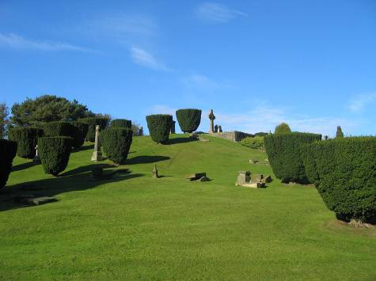
Northhall Cemetery – Site of Fife’s Ancient Legal Centre?

