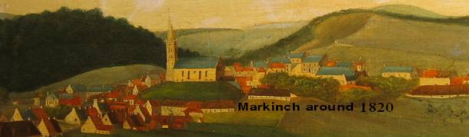

Markinch Heritage Group Research Report No. 15

The Moultries, Lords of Markinch and Neighbours from Hell?

Perhaps because their sources relied upon the Whig and Protestant families of Fife, the early historians such as Sir Robert Sibbald make little more than passing reference to the Moutrie family. Subsequent local historians omit mention of them entirely. However, there was a dynasty of at least nine successive Moutries, Lords of Markinch from the 1300’s through to the 17th century, when they were succeeded by the Laws and the Earls of Leven. Their name is variously spelt Moultray, Moultry, Moultrie, Mutrie etc and it even appears that father and son deliberately chose a different spelling in order to distinguish themselves. By the end of that century, their Markinch holdings were reduced to a quarry on the edge of Markinch. The family seat was transferred to Roscobie near Dunfermline and the last male heir of that subsequent lineage died in 1794 after a distinguished naval career1.

The family origins are obscure. When in the 12th and 13th centuries the Earls of Fife (and the great families that inherited the lands around Markinch from them) began to transfer their interest elsewhere, the Moutries (with many variations on the spelling) began to carve out a barony centred on the ancient settlement of Markinch. By 1384 when we pick up our first charter evidence2 of a Moutray referring to himself as “Lord of Markinch”, the town had long lost its former importance at the heart of Fife and the Earldom of Strathleven.

The original Earls of Fife, descended from the Duff lineage seem to have moved away from the area to Falkland and Cupar shortly after the church was built in the 12th century. It is presumed that the land they once held from the Crown was either sub feued to their supporters or reverted to the Crown for redistribution. The Valences (also spelt Vallance, Valognes or Valoniis) came to occupy the estate of Dalginch located somewhere on the other side of the Back Burn from the church, perhaps at Northhall or a little further to the south. The family home was closer to Markinch than the present day farmhouse of the same name. There is charter evidence of their occupation from 12843, when William granted land to the east of the church, until around 14004 when the last female heir settled in Dalginch with her second husband John Cockburn.

Here at Dalginch, close to the centre of Fife as we know it today and not far from the border between Fife and its ancient sister kingdom of Fothriff, it is possible that legal disputes had been settled for generations, probably back into Pictish times. Dalginch is listed in a 12th century legal text alongside such eminent locations as Aberdeen, Inverness, Perth and Forfar and must have once had some considerable significance.5

Perhaps because the site was difficult to defend, the focus of the Valence landholding shifted to the castle of Inchgall in Loch Ore. The family kept the Dalginch estate but appear to have feued some of the Markinch lands to the Moutries who began to build a barony around the church as they acquired land or feued it from other large landed proprietors of the area. The word moultrar means the collector of the lord’s corn revenue, and the family could have been descended from the millar that had that task on behalf of the Earl of Fife. Alternatively they could have been granted the barony in return for military service to the Earl or the King. The name was also known in Edinburgh during the time of David II, by which time a second Earldom of Fife had been established.6

In 1443 they received a royal charter confirming them not only in their Markinch lands but also in lands of Seafield (close to the port of Kinghorn) where they had built a tower.7
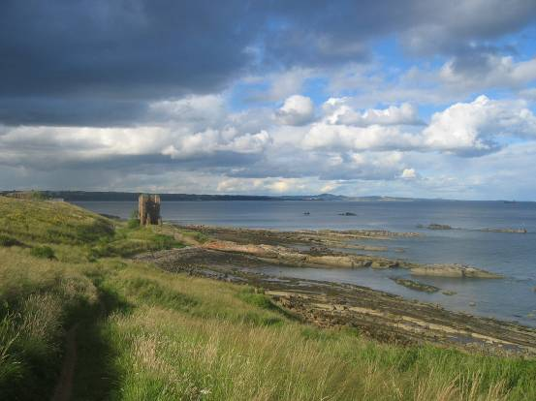
In the 1480s they are recorded as acquiring possession of Cadham and Cadham Mill on the Leven8 and part of the land around Schythrum Mill further downstream.9 By 1491 their Markinch holdings also included Easter Markinch, 6 acres of Dalginch, and the lands of Inchawne (Inchunie) and Pertynhaglis (Pittenhaggles).10 It was not long before they expanded to the lands of Newton of Markinch to the north and possibly to Bighty in the south.

Although not of the highest nobility, the Moutries seem, at least in the 14th and 15th centuries to have been well respected, adjudicating on occasion in a dispute between the great families of the area.11 Later generations were less admired due to a blood feud that broke out with the Melvilles of Raith.

The Lords of Markinch and Seafield, as they were by the late 15th century, now had ready access to the Capital via the port of Kinghorn. Their neighbours were the Melvilles of Raith. A dispute over a debt in the 1490s led to one of Melville’s supporters killing Thomas Moutrie. The murderer happened also to be Moutrie’s brother-in-law, which made matters worse.

Moutrie’s son John took up the feud on his father’s behalf but the Abbot of Dunfermline hastened to patch up the dispute with the award of 12 merks per annum to be disponed upon a priest to pray for the departed father’s soul.12 It is interesting to note that this is the same sum as was used in ancient times to absolve the Macduffs from legal culpability. The money was to be spent upon a chaplain who would celebrate yearly Mass for the soul of the dead member of the Moutrie family.

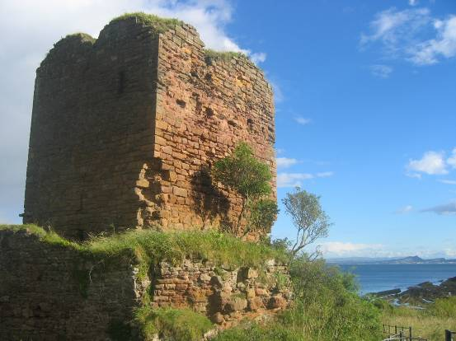

In 1495, he had entered into a complicated marriage arrangement with Margaret Wemyss, daughter of Lady Wemyss of Leuchars and her then husband, rejoicing under the name of Baldred Blackadder.13 Margaret was a daughter of a previous marriage to Alexander Ramsay, heir to the ancient Brackmonth estates and perhaps a class above Moutrie. The deal was that a year’s revenue from the estate would be given to support the marriage provided that the two did not marry without the consent of Baldred and Margaret senior. John’s lairdship cannot have lasted long as another John is recorded as succeeding him in 1504.

His incumbency was even shorter as he was killed at the battle of Flodden in 1513.14 His successor, yet another John, sought revenge on the old family enemy through deviously forcing up the rental on Melville’s lands. However, shortly afterwards, Moutrie’s own goods were forfeited to the Crown on account of a separate manslaughter charge. Melville and neighbouring lairds accompanied the King’s messenger onto Moutrie’s lands to seize the goods and the feud grew even more bitter. 15

John Moutrie’s first vengeful act was the attempted ex-communication of Melville. When this failed, he took the law into his own hands and, with his servants, attacked Melville as he came out of Kinghorn church. The result was the death of one of his own men. Over the succeeding months, Moutrie and his men lay in wait for Melville on a number of occasions. The Vallances of Pitteadie were persuaded to pitch in on the side of the Moutries, perhaps on account of the old feudal relationship between the families.

The nobles of Scotland were split between pro-English and a pro-French factions. This split was exacerbated when the generally pro-English Protestant cause began to gather momentum. In 1529, Moutrie, who remained staunchly Catholic, heard that Melville was on his way to Kirkcaldy to meet Archbishop Beaton. The court records do not state the reason for the meeting. Moutrie roused his ally Valence (Vallance) and a few followers from a local drinking den and stood with a band of fully armed followers in Kirkaldy High Street waiting for Melville to appear. Melville was without defensive armour and approached on horseback. Neither side would give way and in the resulting brawl, Valence (Vallance) was slain and Melville was seriously wounded.16

Moutrie’s bullying was not confined to Melville, however, and the legal accounts of the time show him to be a difficult neighbour, smashing the Vicar of Kinghorn’s plough, building dykes on his land and grazing sheep in his pastures. His other Seafield neighbour, Kirkcaldy of Grange fared little better. Moutrie’s ally, Valence (Vallance) resorted to another attack in Kinghorn churchyard, this time resulting in the accidental wounding of the sister of Kirkcaldy.

The feuding became so bad that King James V was forced to intervene personally in 1533, arranging at Cupar for umpires to reach an amicable settlement between the warring factions.17 The Moutries were confirmed in their former compensation arrangement of 12 merks per annum for the original killing and this continued for many years. This appears to have been a renewal of the sum granted four decades earlier to the son of the original victim to be spent upon a priest who would celebrate a mass “in a fitting place”.

As Roman Catholics, the succeeding Moutries were supporters of Mary Queen of Scots. George Moutrie, the seventh Laird, fought for her at the battle at Langside, being consequently tried for “slaughter”. Henry Moutrie, his son, was the last laird to style himself “of Markinch and Seafield” and thereafter the heir was referred to as “of Rescobie, olim (formerly) of Markinch”. There is little doubt that the feuding was made worse by the religious and political differences of the families involved.

Henry was described as “a wild and unsteady man, hampered by debt” and lost most of the Markinch lands initially to the Lundie family in the early 1600s, dying unmarried in 1618. The family held on to Markinch Law (at the western end of the Balbirnie Estate) until 1673. Indeed one charter refers to Henry’s brother and heir Robert as “Roberto Moutray de Law” in 1619, presumably a reference to the Markinch Law, the last of their Markinch connections.18

The Moutrie’s neighbours and feudal superiors, the Wardlaws (successors to Vallance), appear to have become indebted at about the same time, and the Law family of Brunton purchased the Markinch and the Dalginch lands (according to Sibbald writing in 1710). James Moutrie made an attempt to reclaim his lost estates by marrying a daughter of James Law of Brunton in 1646 and appeared set to become heir, thus reclaming his ancient inheritance. In 1673 Charles II granted James Law the barony and burgh of Markinch, with nearby Brunton (see picture below), Law’s home, to be the principal manor, but the Moutrie name was never again to be associated with the barony as much more portentous events of history were to intervene.
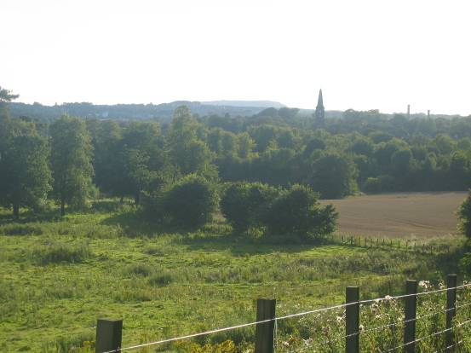

The Laws were to hold the honour for a mere eight years before Melville’s second son David was granted the barony in 1681, when James Law of Brunton resigned. This was a final and triumphant victory for the Melvilles in an ancient feud with the Moutrie dynasty.19 After a brief period of exile, Melville returned along with William of Orange in 1689 and was appointed Secretary of State for Scotland. The Melvilles married into the Leslie family of Balgonie and the resulting Leslie-Melvilles, Earls of Leven and Lords of Balgonie came into possession of the entire barony.

As the Moutrie family seat moved from the lost lands of Markinch and Seafield to Roscobie near Dunfermline, the family does appear to have held onto land to the west of the town around Cadham, Markinch Law and Bighty.20 There must once have been a second Cadham close to Markinch Law as the two names are used interchangeably21 If the family also held onto its Catholic faith then this may have been the origin of the place name Priesty Hall (later Prestonhall), located on the old road between the Law and Bighty. Perhaps however the name dates from an even earlier time when the priest in residence was funded by the 12 merks of “kindbute” referred to above. Markinch Law was probably a valuable quarry but it too reverted to the Earl of Leven in the latter part of the 17th century, having been mortgaged to one of his relatives by the name of Brymor, a former tenant of the Moutrie family. 22

The last charter reference to the Moutries as landowners comes in 1694. “Renunciation by George Moutray, son and heir of Walter Moutray, and Elizabeth Moutray, sister of said George, of the servitude, contained in their charter of half lands of Markinch, for winning stone in the quarry of Markinchlaw enclosed within the park dyke built by David, Earl of Leven.” 23 By the latter part of the 18th century this land had changed hands again and was part of the Balfour’s growing estate of Balbirnie.

The Moutrie of Roscobie links with Markinch were finally severed. Their sole possession was now Roscobie and the surrounding lands of Bairnbathies, an estate near Dunfermline. Roscobie remained the title of the Moutries throughout the 18th century with several heirs having distinguished naval careers. The wife of a Moutrie even ended up as a lover of Lord Nelson before Lady Hamilton came on the scene. Finally, the last heir, Catherine Moutrie (Moutray) sold the lands of Roscobie in 1801 to marry the Archdeacon of Meath.24 The lands within the barony of Markinch were finally purchased by a branch of the Balfour family in 1824.

1 Moultray of Seafield and Roscobie Now of Favour Royal, Co. Tyrone, Marquis de Ruvigny and Raineval, London 1902
2 NAS GD1/101/1
3 St Andrews Liber 420-421, translated by Simon Taylor
4 NAS GD15/390
5 Æ. J. G. Mackay, Fife and Kinross, 1897
6 Fœdera Letteræ I p.772 (quoted by Raineval above)
7 Ruvigny and Raineval, p36
8 NAS GD26/3/13
9 NAS GD26/3/14
10 NAS GD26/3/796
11 NAS GD16/41/3
12 NAS GD26/3/279
13 NAS GD82/38
14 NAS GD26/3/836
15 Ruvigny and Raineval
16 Melville Book, iii, pp70-77 (quoted by Raineval)
17 Ruvigny and Raineval, p. 44
18 ibid p. 47
19 NAS GD26/3/950
20 NAS GD26/3/249 and NAS GD26/4/926
21 NAS RHP 24335 (see also NAS GD/288)
22 NAS GD26/3/953
23 NAS GD26/5/661
24 Raineval op cit

1 Moultray of Seafield and Roscobie Now of Favour Royal, Co. Tyrone, Marquis de Ruvigny and Raineval, London 1902
2 NAS GD1/101/1
3 St Andrews Liber 420-421, translated by Simon Taylor
4 NAS GD15/390
5 Æ. J. G. Mackay, Fife and Kinross, 1897
6 Fœdera Letteræ I p.772 (quoted by Raineval above)
7 Ruvigny and Raineval, p36
8 NAS GD26/3/13
9 NAS GD26/3/14
10 NAS GD26/3/796
11 NAS GD16/41/3
12 NAS GD26/3/279
13 NAS GD82/38
14 NAS GD26/3/836
15 Ruvigny and Raineval
16 Melville Book, iii, pp70-77 (quoted by Raineval)
17 Ruvigny and Raineval, p. 44
18 ibid p. 47
19 NAS GD26/3/950
20 NAS GD26/3/249 and NAS GD26/4/926
21 NAS RHP 24335 (see also NAS GD/288)
22 NAS GD26/3/953
23 NAS GD26/5/661
24 Raineval op cit Picture of Markinch in heading reproduced by kind permission of Markinch Parish Church Bruce Manson November 2007 bruce.manson@btinternet .com

