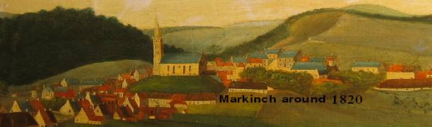

Markinch Heritage Group Research Report No 16
The Landholdings in and around Markinch

The following is an attempt to use the available charter evidence to reconstruct the broad landholding pattern in and around Markinch over the past nine centuries. The objective is to provide a framework for further research, including future work connected with retours and sasine information, not included in the review and some material from Church records.

The Barony of Dalginch

Æ. J. G.Mackay (1897)1 put forward the view that Dalginch was the capital place of Fife where justice was administered and in particular where the warrantors of goods challenged as stolen had to appear. Cunningham2 is more precise, citing three versions of a document that all refer to Dalginch in this context. These are the Latin texts from the 1175 Assizes of King William3, the Regiam Magestatem (book 1, cap. XIX)4 and the Scots translation by Sir John Skene5. In this set of documents, Dalginch is grouped with up to eight other centres of power in northern Scotland6

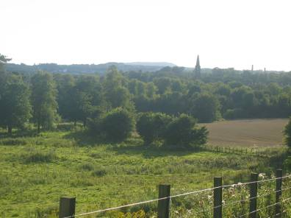
If this was a centre of power and the administration of justice in the 12th century, then it is likely to have had a strong connection to the Earls of Fife, and may even lay claim to have been one of their principal residences. There is likely to be a particular connection with Constantine known as a Judex or senior legal officer of the king. This centre of power appears later to have become the focus of the barony of Dalginch (perhaps part of the larger Earldom of Strathleven) that was carved out for one the southern families that owed knight service according to the new social arrangements that developed from around the time of David I.

There is some evidence that the Ramsay family (Ness of Dalginge)7, originally from the royal estates in Huntingdon, were landholders of Dalginch in the 12th century and much firmer evidence that the possibly related family of Valence or Valoniis was in occupation during the 13th, 14th and into the 15th centuries.8 The extent of the barony is not clear, but it probably once abutted the boundaries of the Church of Markinch, as adjacent glebe land was gifted to the Priory of St Andrews by William de Valoniis in 1284.9 In the same charter, William asks for the monks of St Andrews Priory to pray for the soul of his father as well as the soul of Malcolm former Earl of Fife. This may indicate a direct feudal allegiance between Valence (Valoniis) and the Earl. The Ramsay family continued to hold land to the north of Dalginch at Clatto in Kettle Parish and possibly Balfarg (Balquarg), indicating perhaps that their original Dalginch landholding was substantial.10 It may even have had a fortified manor house or timber castle, one of the candidate locations being the mound at Northhall cemetery.

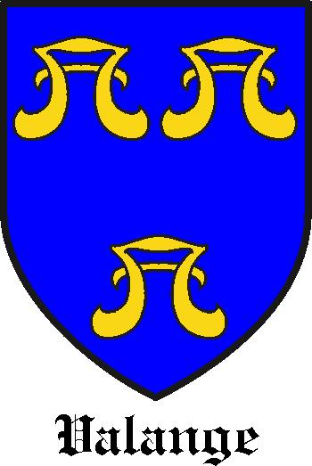
When the Vallance or Valoniis line began to run out of male heirs at the beginning of the 15th century, the family’s various Fife landholdings were already consolidated around a major barony centred upon the island of Inchgall in Lochore but including Dalginch as an outlying landholding. The family name that succeeded Valence through marriage to Christian, the only surviving daughter, was Wardlaw and the name “of Torry” became associated with the Lochore (Inchgall) barony. Torry was a landholding of the Wardlaws in Torryburn Parish to the west. During the 15th century, the Wardlaws focussed their attention on affairs of state and on the Lochore and Torry parts of the Barony, leaving Christian’s second husband, John Cockburn, to look after “the town of Dalgynche and the Burntoun” under a secured rental agreement.11 After styling themselves “of Dalginch” for a number of years, the Cockburns came to be associated with the neighbouring estate of Treaton They do not appear ever to have held feudal superiority which remained with the Wardlaws. The Valence family name survived in Fife but only in a minor landowning context. In 1529, the “Vallances” of Pitteadie are found fighting the Melvilles in the streets of Kinghorn alongside their neighbours the Moultrays of Markinch and Seafield (Raineval 1902). The old French pronounciation of the surname may be retained in “Valange”, reportedly the name of a witch tried in Fife in the 16th century.

The Moultrays had styled themselves Lords of Markinch from the 14th century at least and later added the title of Seafield, a castle between Kirkcaldy and Kinghorn. They appear from a charter of 1512 to have been infeft to Henry Wardlaw of Torry12 who would also have been the feudal superior of the Dalginch lands. This may indicate that the Moultray lands referred to in the Wardlaw document (Easter Markinch (Est-Markinch), Nether Markinch (Nethir Markinch), Bighty, Pittenhaggles (Pettinhaglis), Inchunie (Inchehony) and 6 acres of Dalginch meadow) were at that time contained within the larger barony of Torry, as indeed was Dalginch itself. The barony of Dalginch therefore seems to have been absorbed into the larger barony of Lochore (later Torry) at the same time as Moultray, baron of Markinch was assembling land and developing its separate as a separate barony in its own right. By the mid 16th century Lochoreshire comprised Brunton, Dalginch, the Lake of Balfarg, Treaton, Easter and Wester Newton and the patronage of the Chapel of Inchgall. 13 No specific mention is made of Markinch, unless it was assumed that Markinch was contained within the Dalginch barony.

John Cockburn’s descendents David, Alexander and Andrew Cockburn of Treaton sub-feued mireland to their southern neighbours the Lundies of Balgonie during the 16th century 14. The Wardlaw family seems to have resumed a closer interest in their Dalginch inheritance and may even have reoccupied the estate. Despite a strategic marriage to the Rothes family in 1605, the Wardlaws were in debt to the Lundies by 1617 and the feudal superiority of Markinch passed out of their hands.15 The Moultrays were also in debt around this time, also to the Lundies 16, and there was a complete change of land ownership in the town.

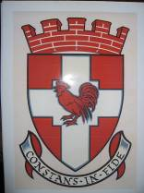
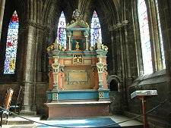
In 1632, George Law of Brunton (a landholding on the Dalginch estate) called in a debt to the Moultray family, which resulted in the Laws acquiring some of the Moultray lands (Roscobie, Blairinbathies and Woodend are specifically mentioned), according to Sibbald, with assistance of a relative, Archbishop Law. The Archbishop married a Mariota Boyle in 1620 and she was granted the life rent of the Markinch lands formerly belonging to the Moultrays in 1627. She erected a monument to her late husband in Glasgow Cathedral (above left), following his death in 1632. According to Raineval,17 the family genealogist, James Moultray married the second daughter of James Law of Brunton in 1646 leading to the reinstatement of the superiority to the Moultrays over these lands following the resignation of the Laws, but this is not corroborated elsewhere and may be a family fiction designed to cover over a major dynastic disaster. There is still some confusion over the transfer of land in the area at this period, although Sibbald clearly states that James Law purchased the Dalginch estate from the Wardlaw family. Sir William Purves carried out an enquiry in to the King’s revenues in 1667 and listed “the south side of Balbirny, Brunton and Dalginche, Markinch Easter, Markinch Wester, Treaton and Newton” By far the most valuable of these was “Brunton and Dalginche.”

In the 1670’s Charles II re-created a combined barony of Markinch and Dalginch along with burgh status for the town, granting it to James Law of Brunton.18 The Law family’s rapidly acquired social position in the locality did not last long however. After service to William of Orange, George 4th Earl of Melville, descendant of Moultray’s old adversary Melville of Raith, returned from exile to the position of Secretary of State for Scotland. Within a short period of time, his son, David was granted the charter for “the town and lands of Markinsh, Over or Easter Markinsh called Kirk Markinsh, lands of Nether Markinsh, Bightie, Pittanhagils, Inshinine, Treattoune, three parts of Bruntounland called three Mires, Brounshaugh, and others pertaining to the burgh of Barony of Markinsh, following on resignation of James Law of Bruntoune.”19 This is essentially the list of lands contained in the Burgh Charter with the addition of “Inchinine” which may have been an omission from the charter, unless it was already in the hands of the Balfours.

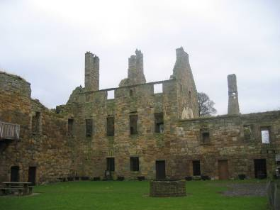
Melville’s Countess, Catherine, daughter of Alexander, Lord Balgonie, (son of General Alexander Leslie) fell heir to the estate on his death in 1707. David, 2nd Earl of Melville succeeded on the death of his mother in 1713. The fortunes of the Leslies and the Melvilles were in the ascendant and the Lords of Leven and of Balgonie (the title of the heir) found themselves in possession of much of Markinch town and the surrounding area. The Arnotts later came to occupy the Dalginch estate (followed later by the Simpsons and the Pastons) while the earls of Leven feued out land in and around Markinch throughout the 18th century.

The Markinch Landholdings of the Moultries

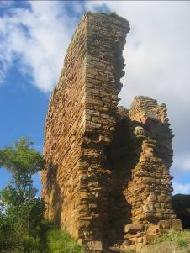
The Moultray family seems to have dominated Markinch from the late 14th century until the early 17th although they are unlikely to have been the feudal superiors. The family heads had been calling themselves “Lords of Markinch” since the late 14th century and a Moultray signature is to be found on a charter of 1384 underneath that of Vallance (Valons kt.) possibly his feudal lord.20 The family may even have predated Valence and have been connected to the original Earls before their focus shifted to Falkland and Cupar, but there is no direct charter evidence for this and their landholding could have been a creation of the second Earldom. The Moultrays used their wealth, perhaps based upon milling or tithe gathering as their name suggests, to increase their Markinch lands from an “Easter Markinch” base around the kirk and a “Nether Markinch” base around the Middle Mill. From an early date their barony included the lands of Pittenhaggles and Inchunie to the west of Markinch settlement, the lands of Schythum in the south and east, expanding later to Newton of Markinch in the North, to Cadham and Markinch Law to the west of Balbirnie and to Bighty to the south of the Leven. It was a barony carved out of the landholdings around the town of Markinch and tied in to a separate landholding on the coast at Seafield near Kirkcaldy, giving them access to the Forth and across it to the Capital.

Many generations of Moultays are recorded, Lords of Markinch and Seafield (their coastal stronghold), but their name was eclipsed by the Leslie-Melvilles, Earls of Leven who as noted earlier ended up in possession of their lands.

The Moultrays were at times held in high regard by their aristocratic neighbours and overlords, adjudicating at one time in a dispute between the Lindsays and the Wardlaws, but do not appear to have been part of the aristocratic landed elite. There was a family tendency towards murdering or being murdered by their neighbours, a state of affairs that necessitated the direct intervention of the king on at least one occasion.21 Old alliances with their erstwhile feudal superiors emerge in the street fights of Kinghorn as late as the 16th century, with the Moultries joining forces with the “Vallances” of Pitteadie to attack their bitter enemies the Melvilles (Raineval, 1902). This feud continued over several generations.

Despite the Moultray and the Wardlaw lineages surviving the carnage of Flodden, both of the families, began to collapse under a weight of debt later in the 16th and early 17th centuries. The Moultray family genealogist claims that they attempted to regain their barony through a complicated marriage arrangement with the Law family (see above). The Moultrays moved their family seat to an estate near Dunfermline and redefined themselves as “Lords of Rescobie formerly of Markinch” and were represented in Markinch by only a few family members down to the mid 19th century. 22 Their last landed links with Markinch were in the areas of Bighty and Markinch Law, lands that the Earl of Leven eventually came to possess.

Western Markinch

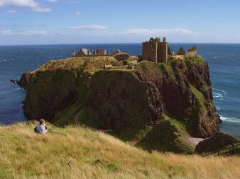
On the western side of Markinch, there is again evidence of early land ownership by the Earls of Fife, with Balbirnie being part of a land exchange agreement involving Earl Duncan II and Orm son of Hugh as early as the 1160s or 70s. It has been argued that this was part of a process of securing the territory of the Earldom of Strathleven for the Fife Earls, part of a move from kinship to land based allegiance within the developing feudal system.23

When the first line of Fife Earls was finally extinguished in the 14th century, a new Stewart earldom was established, and Wester Markinch seems to have been granted to the Keith family, Marischals of Scotland who held the territory until it was part exchanged in 1392 for the early fortress and rock upon which Dunottar Castle was built, then held by the Lindsays.24

This was part of a land deal involving the lands of Struthers near Ceres and may point to some of the earlier landowners in the area if these two landholdings were in some way connected. “Westyrmarkynche” as it was called in the charters became linked to the lands of Kirkforthar, once ruled over by the Lord Lindsay of the Byres. Kirkforthar is on the border between Markinch parish and Kettle and if the house was built on Wester Markinch lands, then the landholding was considerable although not necessarily contiguous. The Lindsays may have had land interests as far south as the Leven.25 The Moultrays were at one time referred to as “of Eister Markinch” and this may point to an early division of the territory of Markinch (ie the earldom of Strathleven or a substantial portion thereof) between Easter and Wester, perhaps sharing a mill or the place of worship.

It is not yet clear whether Balbirnie was part of the “Westyrmarkynche” referred to in the Lindsay - Keith charters or adjacent to it. The name “Wester Markinch” later came to refer to a cluster of houses on the road out of Markinch but it may well have been a more substantial estate. The Balbirnie land was probably ceded at an early date to minor barons in exchange for military service. According to Cunningham (1907, footnote 2) the land was divided at an early date between the Inglis and the Seatons and by the mid 17th century it was in the hands of the Clerk family.26 They sold out to an incoming branch of the Balfour family27 who, over 300 years, exploited its coal reserves, laid out the estate and used it as a base for the expansion of their landholdings up until relatively modern times.

To the north west of Balbirnie, the Templelands around Balfarg28, most probably owned by the Knights Templar in the 12th and 13th centuries, may also have had an independent status. Archaeological evidence has pointed to a well constructed early mediaeval lade, probably built for a fulling or waulk mill, cutting right through the Bronze Age ceremonial complex.29 It points to the importance of sheep rearing in the area and to an early weaving industry. Pottery had been imported from as far away as southern England. However, judging by the value (30p)30 this estate (or perhaps toft) was probably only about 15 acres in extent and may have been attached to or contained within a larger landholding of Balfarg. The estate later fell into the hands of the Bruce family followed by Wemyss of Balfarg31 and then to the King’s Master Mason, Robert Mylne, responsible for building Holyrood Palace and much of Edinburgh during the latter part of the 17th century. Eventually, Mylne sold out to David, Earl of Leven along with lands around Spittal (present day Thornton) also owned by Milne.32

Newton of Markinch and the lands to the North of Markinch

To the north of the town, the lands of Newton of Markinch had been part of the Moultray landholdings since 1511 at least.33 It is unclear from the charters who the original feudal superior was but the term “of Markinch” indicates a strong tie to the town and that probably derives from the Moultray family, indicating a Wardlaw rather than a Lindsay superiority. The lands changed hands several times with the Wemyss, Erskines and Dalrymples being prominent in the 17th and 18th centuries. Newton was later incorporated into the Barony of Markinch created by Charles II for James Law in 1678 before, as noted, the land was taken over by the Melville family, later the Earls of Leven (Leslie-Melvilles) and finally by the Balfours in the 19th century.34

The Landholdings of the Earls of Leven and the Balfours of Balbirnie

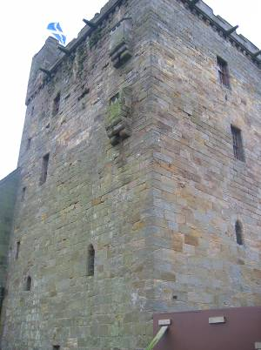
Balgonie Castle and surrounding lands had been held by two great families, the Sibbalds and the Lundies, each family supplying the King of Scotland with at least one Chancellor. The Lundies were succeeded by Sir Alexander Leslie, appointed Earl of Leven in 1642 by Charles I. The 18th century saw the further rise of the Earldom of Leven (later the Leslie-Mevilles) and the Balfours of Balbirnie, both seeking to exploit to the maximum the resources of their respective estates – coal, iron and water power.35 Road and rail links were expanded and factories developed along the Leven. Their land acquisition approached Markinch from different directions with the Earls of Leven holding the lands around Spittal to the south and west of Markinch in the late 18th century as well as much of Markinch settlement, and the Balfours acquiring lands around Newton in the north and latterly Inchunie close to the present date esate entrance. Where the two landholdings eventually met, as along the top of Markinch Hill, a line of solid boundary stones was put in place. Both estates became involved in commercial enterprises but it was the Leven estate that was first to feel the economic pressure. After a series of business failures relating to an iron working in the early part of the 19th century36, the estate sold out to a branch of the Balfour family in 1824. The Balfours now became the principal landowners in the parish and in the town itself and the Leslie-Melvilles, who now held the Earldom, retreated north.

The ancient coalmines that dotted the Balbirnie estate were shut down or covered over and a pleasure estate was created amidst what must once have been a landscape scattered with mine workings and spoil heaps or “prickings”. The place names Blacklaws and Prickhills both seem to relate to the early exploitation of coal on the estate. The Ballingal family, a particularly talented and energetic dynasty of factors for the Balbirnie Estate, contributed greatly to the improvements that enabled the town to prosper and expand until the coming of the new town of Glenrothes in the latter part of the 20th century.

Sythrum and Cadham

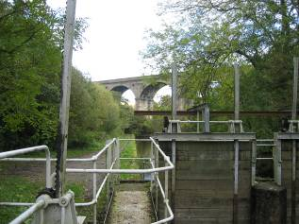
Late 15th century charters refer to a Lordship of Schethum (Sythrum) and Calldame 37 freely held by Andrew de Schethome38 and Thomas, his father. There may once have been a second Cadham closer to Balgonie Castle. This is a stretch of the Leven that must have had considerable economic significance with the potential for several water mills. After a complex series of charters39 covering 1486 to 1500, Robert Lundie of Balgonie secured these lands on both the north and the south sides of the Leven40 and they later passed into the hands of the Earls of Leven. During this process, the Moultrays of Markinch must have secured freehold of Cadham41 within the Balgonie superiority, as two separate heirs are recognised by “precept of clare constat” in 157242 and again in 160543. The Moultrays were still in possession as late as 1673 when the lands were transferred to John Brymor (Bremner). This charter equates Cadham with Markinch Law, indicating that the common name of Cadham occurred twice in the Markinch area.44. The final charter linking the Moultrays with Markinch was in 1694 when George Moultray and his sister renounced the servitude contained in their charter of the half lands of Markinch for winning stone in the quarry of “Markinchlaw” enclosed within the park dyke built by David Earl of Leven.45 This was one of the landholdings that transferred from the Earls of Leven to the Balfours of Balbirnie in the late 18th century. There was some dispute between the Balfours and the Earl of Rothes over the underground boundaries of their respective estates as this was a piece of land underlain by substantial coal reserves.

Conclusion

Amidst all this charter detail, is it possible to see a wider picture?

It seems likely that that the lands of Markinch made up a substantial territory based upon or including a sizable portion of the Earldom of Strathleven.46 These appear to have been split in two some time during 12th century, perhaps when the first line of Earls of Fife were transferring their interest away from Markinch. It is possible that the Ramsays and certainly their close kin, the Valences (Valoniis) assumed the feudal superiority of the Easter Markinch landholding focussed upon the ancient centre of Dalginch but including land that abutted the church (this is demonstrated by a land grant to the church in 1284 9). The feudal superiority of this land passed by marriage to the Wardlaws. The Cockburns held the land but not the superiority before it reverted to the Wardlaws again in the mid sixteenth century. It was bought out by the Law family who held it for a short time before it was absorbed into the estates of the Earls of Leven around 1700.

Wester Markinch may have been have been granted to another incoming family as the MacDuff earls relinquished control. The Barony could have abutted the church on the other side and there may have been shared arrangements for the grinding and ingathering of grain, although there is no direct evidence for this. These two original landholders of Easter and Wester Markinch would have been significant supporters of the Earl in terms of knight service. Further down the Leven valley similar units were created for the predecessors of the Sibbalds and the Lundies. Unfortunately the charter evidence for this Western Markinch landholding is less strong than that for the east, although the families of Inglis, Keith and later Lindsay may have been the equivalents of the Valences and the Wardlaws, that issupporters of the Earls of Fife.

Within each of these superiorities, freeholders would have been established, both for revenue and military purposes. One such freeholder, Moultray (variously spelt Moutrie etc), was able to carve out a small barony, initially on the edge of the Dalginch landholding (Inchunie, Pittenhaggles, Easter Markinch and six acres of Dalginch). This could have comprised that tract of land from Stob Cross and the road to the north as far east and north as the Back Burn including Markinch Hill, much of Markinch settlement and the haughland north of the Glebe. As Dalginch itself became a peripheral part of the wider barony of Inchgall, the power of the Moultray dynasty increased. They extended their influence to the south and held possession of Markinch Law in the south and Newton in the north. The Moultrays had sufficient wealth to be able to secure a stronghold on the coast at Seafield on the route to the key port of Kinghorn.

Another freeholding family were the Lairds of Schethom (Sythrum), who held an economically important strip along the Leven, but who relinquished it, partly to the Lundies and partly to their neighbours and fellow freeholders the Moultrays. It later came into the hands of the Earls of Leven along with territory around modern day Thornton, known then as Innerlochty or Spittal.

The feudal superiority of Wester Markinch fell into the hands of the powerful Keith family during the time of the second Fife Earldom (14th century). Balbirnie may have become detached from a wider landholding and become a freely held unit in its own right, perhaps akin to the aforementioned lordships or baronies of Markinch and Sythrum. As some stage, Balbirnie was split into two separate landholdings. The superiority of the remaining lands of Wester Markinch were traded by the Keiths resulting in the Lindsay family taking feudal possession of at least part of Wester Mankinch.

The picture is further complicated by the landholdings to the north of Markinch. Although the superiority seems to have remained in the hands of the Wardlaws, this land also fell into the Moultray barony and came to be known as Newton of Markinch, the land to the north of the Back Burn.

This gradual accumulation of lands from surrounding landowners meant that when the Moultrays were enumerating their possessions for charter purposes it was necessary to include all the elements of past purchases or sub feuing arrangements. These were Easter Markinch, Inchunie, Pittenhaggles, 6 acres of Dalginch and later Bighty, and Newton of Markinch. These were the units that the family gradually assembled over 300 years and that they lost through debt in the early 17th century. This, with the addition of Dalginch and Brunton, was essentially the land package that was later fused into the Burgh of Barony of Markinch in the 1670’s, and assembled or perhaps reassembled into a superiority in its own right this time under direct charter from the monarch.

As noted above, the burgh was rapidly acquired by the Melvilles, old adversaries of the Moultrays, and became part of the lands of the Earl of Leven when the earldoms of Melville and Leven were united. Markinch grew and began to prosper within this burgh structure but the wider Leven estate had difficulty in adapting to the industrial realities of the age. The Balfours of Balbirnie had been purchasing some of this land from the late 18th century and finally a branch of the family acquired the core landholdings within Markinch settlement in 1824 when the Leven estate sold out.

The above is a rough sketch of the landholding situation in the Markinch area using available charter and genealogical records. There is still much to be done in terms of detail and some of the interpretations of the material set out above might subsequently prove to be wide of the mark. However, as no assessment has ever been carried out of this essential aspect of local history, no progress can be made on other fronts until this basic subject is addressed.

1 Æ. J. G. Mackay, Fife and Kinross, 1897
2 A. S. Cunningham, Markinch and its Environs, 1907
3 Assize of Willelmi Regis translated by Cunningham 1907
4 Regiam Majestatem translated by Cunningham 1907
5 Skene, W. F., 1886-90, Celtic Scotland, second edition, 3 vols (Edinburgh).
6 (Scone in Gowry, Cluny in Stormont, Raith in Athol, Kyntonloch or Perth in Strathearn, Forfar in Angus, Dunottar in Mearns, Aberdeen in Mar and Buchan, and Inverness in Moray and Ross). Quoted in Robert A. L. Smith, The History of the House of Lundy 2003
7 H. Milford, Bamff Charters AD 1232-1703 – p10
8 St Andrews Liber 420-421, Etiènne de Pattou, Famille de Valognes (corresp), NAS GD254/2 (Papers of the Lindsays of Dowhill),
9 St Andrews Liber 420-421
10 NAS GD 82, NAS GD 20/1/195
11 NAS GD15/390
12 RMS ii no. 3738 (cited by Gilbert Markus 2007)
13 NAS GD15/672
14 NAS GD26/3/52 -55--61-62-64-65-67-68-69-71
15 NAS GD26/4/707
16 NAS GD26/3/825
17 Marquis de Ruvigny and Raineval, Moutrie of Seafield and Roscobie, 1902
18 Markinch Burgh Charter, Fife Council Archives
19 NAS GD26/3/950
20 GD1/101/1
21 Sir William Fraser, The Melvilles of Melville 1890
22 NAS GD124/1/693
23 G.W.S. Barrow, The Kingdom of the Scots, 1973
24 NAS GD 20/1/5
25 NAS GD26/3/11 (this should read Patrick Lindsay of Kirkforthar and is a mis-transcription)
26 NAS GD446/28
27 NAS GD29/734
28 NAS GD20/1/346
29 C. J. Russell-White, Mediaeval Features and Finds from Balfarg/Balbirnie, Fife, Proc. Soc. Antiq. Scot, 125 (1995), 1001-1021
30 Maidment Templaria 1829 in A. Ferguson, Unpublished draft
31 NAS GD26/3/231
32 NAS GD 26/3/264, NAS GD20/1/346, NAS GD26/3/231, NAS GD421/9/41
33 NAS GD26/3/835
34 NAS GD/26/3/848, NAS GD26/3/852
35 Balbirnie Park Management Plan gives a good summary. Prepared for Fife Council by Land Use Consultants in association with Patsy Thomson 1996
36 G. P. Bennett, The Past at Work around the Lomonds
37 NAS GD/26/3
38 NAS GD26/3/3
39 NAS GD26/3/4- 48
40 NAS GD26/3/49
41 NAS GD26/3/13
42 NAS 26/3/74
43 NAS 26/3/97
44 NAS GD26/3/248-249
45 NAS GD26/5/661
46 G. W. S. Barrow, The Earls of Fife in the 12th century
9

