Balbirnie East Lodge

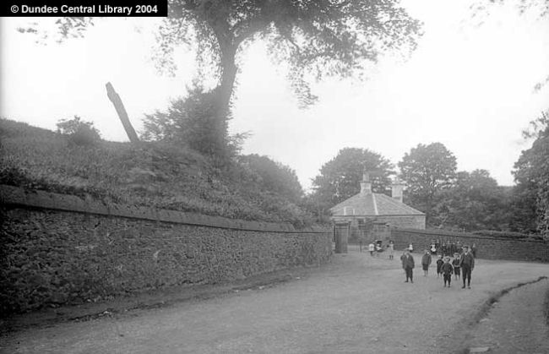

Alexander Wilson, who took this photograph, was a supervisor in a Dundee jute mill for over 20 years. He bequeathed much of his collection and £50, to cover the costs involved, to the Free Library Committee of Dundee in 1923.

Notice the angle of Stob Cross and also how clear the area surrounding it is.

Can anyone put a date on this picture?

